https://www.dailymail.co.uk/news/article-2314647/Has-plastic-surgery-20-Korean-beauty-pageant-contestants-look-Pictures-contest-hopefuls-goes-viral.html

**Has plastic surgery made these beauty queens all look the same? Koreans complain about pageant 'clones' (edited)** [STEVE NOLAN](https://www.dailymail.co.uk/home/search.html?s=&authornamef=Steve+Nolan) 25 April 2013

South Korea's growing obsession with plastic surgery became apparent when pictures of a group of aspiring beauty queens posted online. All the contestants looked the same. Pictures of the 20 Miss Korea 2013 finalists fueled speculation that many of them had undergone surgery.

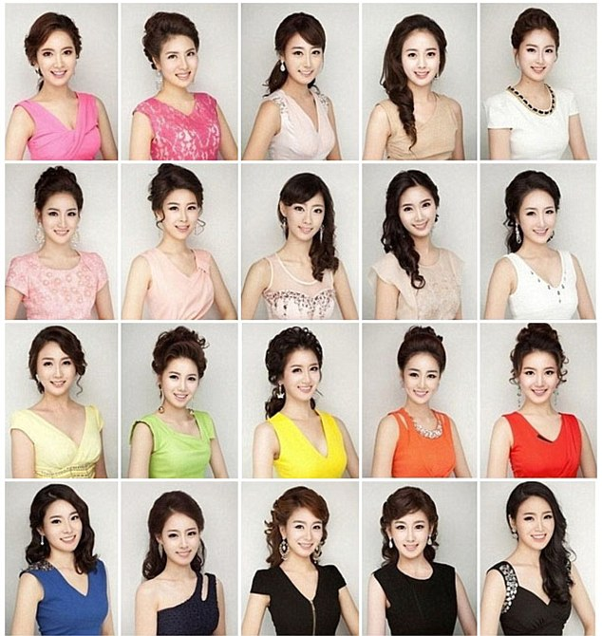

South Koreans currently have more plastic surgery than in any other country according to recent figures. Last year**, 20 per cent of women 19 to 49 in the capital city of Seoul admitted to plastic surgery.**

The popularity of surgery, particularly among the young, has been blamed by some on a desire to look more 'western'.

Some online comments:

* 'Korea’s plastic surgery mayhem is finally converging on the same face.'
* 'This is called the Korean plastic face look. In certain areas of Seoul, you would think all the women are sisters.
* 'Th surgery takes away their individuality. It’s sad.'
* 'They've been brainwashed to think westernization of their features is superior.'
* 'Older women complain how girls don't look Korean anymore because of all the plastic surgery.'
* 'It's so common to the point if I meet a girl, I just assume she has had something done.'
* 'Girls here consider eye surgery just like using make up.'

But others on the social networking site said that all the pictures served to prove was that there is a 'cultural divide' between the east and west in terms of plastic surgery.

The pageant sparked controversy last year when pictures emerged of winner **Kim Yu-Mi** before she had undergone plastic surgery. She defended her crown telling the Korean media: **'I never said I was born beautiful.'**

South Koreans have more plastic surgery than any other nation according to figures released in January.

One of the most popular surgical procedures is double eyelid surgery - which reduces excess skin in the upper eyelid to make the eyes appear bigger and make them look more 'Western'.

1. What percentage of women 19 to 49 in Seoul admitted to plastic surgery?

2. What did Miss Korea, Kim Yu-Mi, say?